Programming Test Assignment – Lusterio, Primo Joven A.  
  
So I replicate the API that returns the stories in my local computer using php laravel, and then test it in Postman if it returns the same response that we had in the given example.

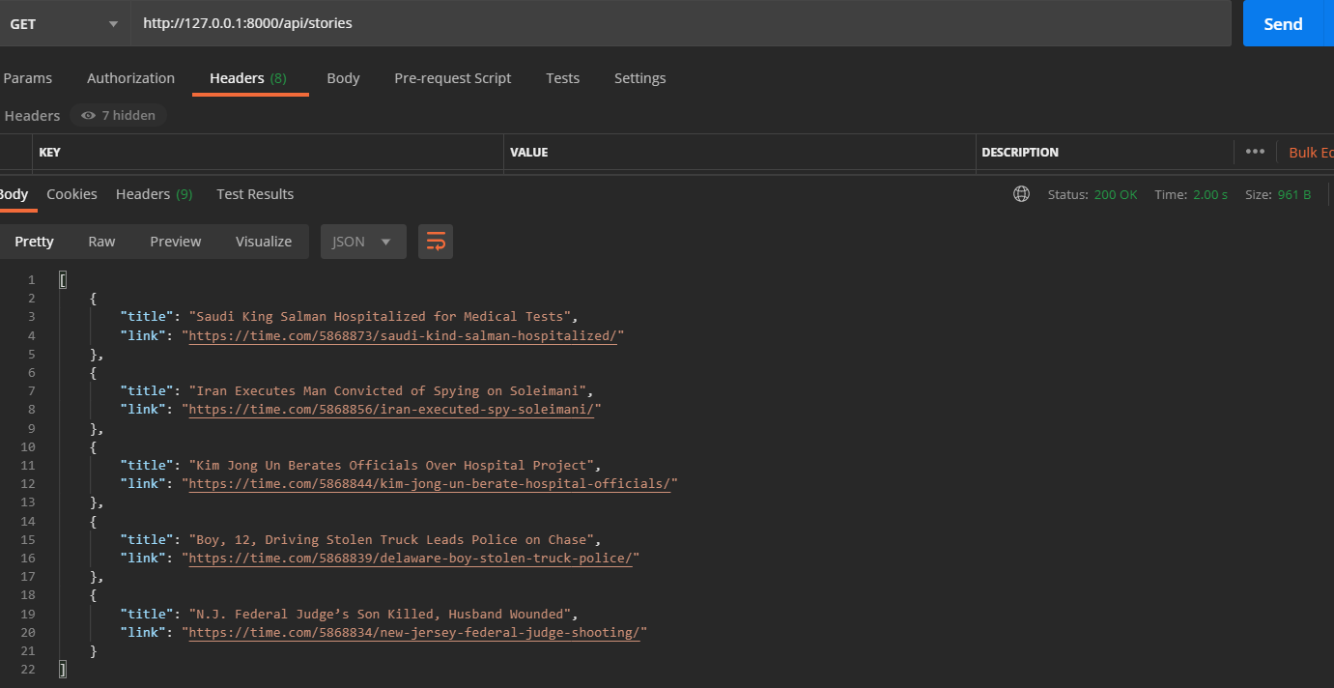

And then I used the fetch function in javascript without using any libraries as said in the instructions. In the code below, I parse the response by creating a loop for each data and assigned it in the list variable and added a *<li>* and *<a>* tags so that when we load the list in the stories element it will return a list of title that has its own link.

<!DOCTYPE html>

<html>

<body>

    <h2>Programming Test Assignment</h2>

    <p id="stories"></p>

    <script>

        fetch("http://127.0.0.1:8000/api/stories")

            .then(response => response.json())

            .then(data => {

                let list = '<ul>';

                for (let i = 0; i < data.length; i++) {

                    list += '<li><a href="' + data[i].link + '">' + data[i].title + '</a></li>';

                }

                list += '</ul>';

                document.getElementById("stories").innerHTML = list;

            });

    </script>

</body>

</html>

